**Design Report**

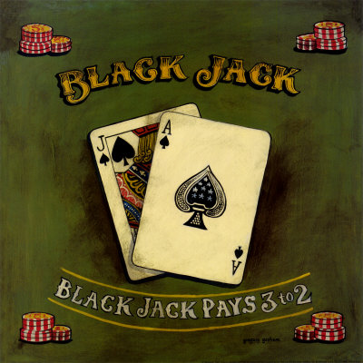

**By:** Thanushan Karunaharan

**Course Code:** ICS3U1

**Teacher:** Mr. Lin

**Date Due:** Friday, June 3rd, 2011

**Date Submitted:** Friday, June 3rd, 2011

Table of Contents

**Request:**

What are you being asked to do ................... 3

**Analysis:**

Rules ....................................... 3

Error Cases .................................. 3

**Design:**

Flowchart .................................... 4-5

Method Signatures .............................. 6

Screen Shots .................................. 7

The request is to create the game of Blackjack using Java Applets in a two week period. This version of Blackjack will be similar to the Blackjack games played at Casinos, but without some of the side rules (such as split, insurance, and surrender).

Request

Analysis

* This is a one player game.
* In the game you are competing against the dealer (or the computer in this case). Both you and the dealer are given two cards with an objective of reaching 21 (hand value) and without going over (called “**Bust**”).
* Each playing card is given a value.
* The cards from 2-9 are their face values
* An Ace can either be counted as 11 or 1 (assumed to be value that makes best hand)
* 10, Jack, Queen, and King are valued at 10
* In the beginning of the game, the player is asked to enter their wager and then both the player and the dealer are dealt their two cards (dealer has one card face up and one card face down, but both yours is face up). At this point, If you get a hand value of 21 with the two cards it is called “**Blackjack**”, and you automatically win the round. After the two cards are dealt and if you don`t get blackjack, the player than has 3 choices...
* ***Hit*** *-* draw another card that adds to hand total value
* ***Stand*** *-* stops at current total
* ***Double*** *-* (only be done when first 2 cards dealt) doubles your bet and receive ONLY one additional card. After this you are forced to stand and see if the dealer loses.
* If player hits and puts themselves over 21, they lose that hand and the wager money. But if the player has a hand that adds up to more than the dealer’s hand (without going over 21) or is exactly 21 the player receives double their wager back. A draw could also occur if both the dealer and the player stand on the same hand value (called “**Push**”). The player receives the exact same amount of money that they waged for that hand.
* The dealer has a specific way that he is supposed to play his hand which is hitting until his total is *greater than 17*.

Error Cases

No error cases due to the user’s actions will occur because the user is only allowed to click buttons. Problems such as the user pressing the wrong buttons at wrong time could occur, but if the programming is correct this error will not arise. So at the end, there will be no error cases given that it is a GUI and that the programming is correct.

Flow Chart: Blackjack

Start

Main Menu

High scores

Rules

Play Game

Sort High Scores from highest to lowest

**NO**

Display Game Table

Record High Score

Ask for Username

Quit

**YES**

Player Enters Wager

Dealer dealt 2 cards (One card face up and face down)

Player dealt 2 cards (Both cards face up)

**YES**

Blackjack (= 21)

**NO**

Double Down

Choices

Stand

Wager doubles and ONE card dealt

Hit

k**YES NO**

Add one card

Hit

Bust (>21)

Dealer’s face down card revealed

Choice

Stand

Dealer Turn

Stand

**NO**

**YES**

Card Hand <17

Add one card

Hit

**YES**

**NO**

Bust (>21)

Player’s hand < Dealer’s hand

Player’s hand > Dealer’s hand

Check Winner

Player’s hand = Dealer’s hand

Lose wage money and round

Gain double wage money and win round

Draw game and receive back wage money

Method Signatures

Method Summary

|  |  |
| --- | --- |
| void | mainMenu()  Displays the main menu. |
| void | helpScreen()  Displays the rules of the game. |
| void | highScore()  Displays the player high scores. |
| void | gameTable()  Displays the Blackjack table (interface of the game). |
| int | wageChips ()  Calculates the number of chips clicked and determines wager for round. |
| int | updateBank ()  Updates the bank after waging and after the outcome for the round (win, lose, or draw). |
| boolean | checkBust ()  Checks if the hand value is greater than 21 or not. |
| void | selectCard ()  Randomly selects one of 52 cards and prints that card. |
| boolean | dealerCondition ()  Checks if the dealer hand value is less than 17. |
| void | sortHighScore ()  Sorts the scores of submitted player scores from descending order |
| void | clickDeal ()  When “deal” is pressed, displays first 2 cards. Both cards facing up for player and one facing up and one facing down for dealer. |
| void | buttonClickability ()  Disables particular buttons at particular times when the choice should be unavailable to the player. |
| void | handValue ()  Displays the hand values of both the dealer and the player. |

Screen Shots: Blackjack

Main Menu

Help Screen

High Score Screen

Game Table Interface

